**Implementation:**

Class Retrieve:

def __init__ (self, index, termWeighting):

* Initialize index, term weighting scheme.
* Construct inverse index dictionary {document id > term > count}.
* Construct document frequency(df) dictionary.
* Compute $\sum_{i=0}^{n}{{di}^{2}}$
* Compute inverse document frequency (idf).

def forQuery (self, query):

* Get Candidate documents.
* if (self. termWeighting == 'tf'):

return Retrieve.tf (query, Candidate documents, inverse index)

elif (self. termWeighting == 'tfidf'):

return Retrieve.tf_idf (query, Candidate documents, inverse index, size of document collection, self. index, document frequency, inverse document frequency)

elif (self. termWeighting == 'binary'):

return Retrieve.binary(query, Candidate documents, inverse index)

else:

return Retrieve.binary(query, Candidate documents, inverse index)

**Performance evaluation:**

Here we are evaluating the system based on the ranked retrieval approach. Document retrieval is carried out using three-term weighting schemes which are binary, tf and tf.idf. Considering evaluation metric “F-measure” which is the harmonic mean of precision and recall, the top 5 configurations w.r.t F-measure values considering the first 10 responses for each query are as follows:

|  |  |  |  |
| --- | --- | --- | --- |
| **Configuration** | **Precision** | **Recall** | **F-measure** |
| tf.idf - with stoplist with stemming | 0.27 | 0.22 | 0.24 |
| tf.idf – without stoplist with stemming | 0.26 | 0.21 | 0.23 |
| tf.idf – with stoplist without stemming | 0.22 | 0.18 | 0.19 |
| tf.idf – without stoplist without stemming | 0.21 | 0.17 | 0.18 |
| tf - with stoplist with stemming | 0.19 | 0.15 | 0.17 |

Table : IR Evaluation metrics for different configurations

Figure 1 shows the precision-recall curve for all the above configurations. Ideally, if the precision-recall curve is more towards the upper right corner (which means all the retrieved documents are relevant), then the system is good.

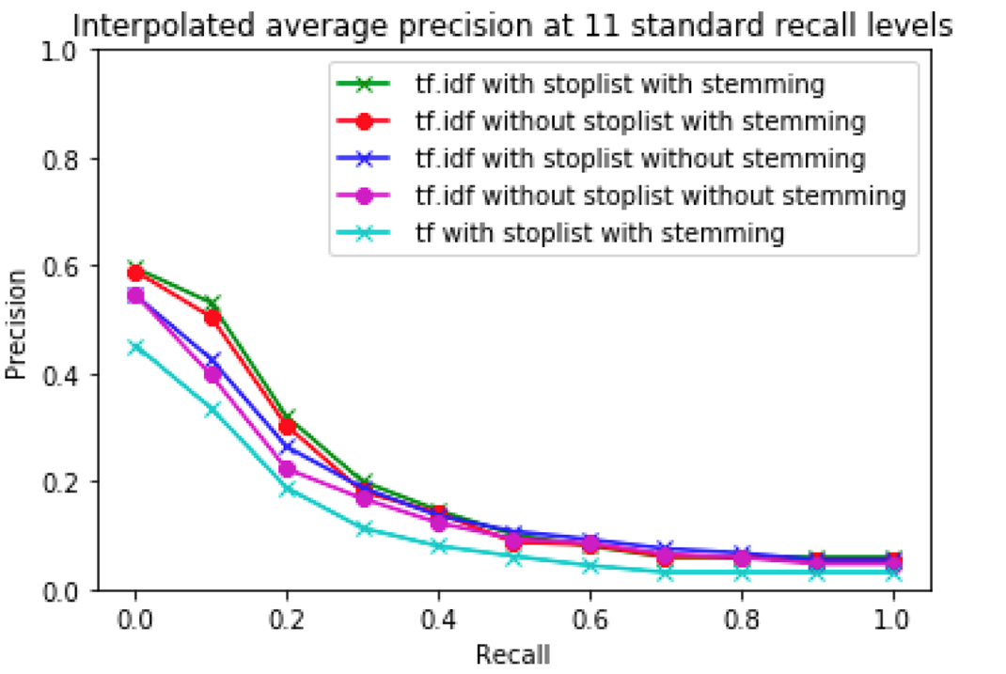

Figure : Precision Recall Curves

Here the requirement of our IR system is to retrieve all and only the relevant documents.

All the curves with different configurations in Figure 1 shows almost similar trend. So here I will consider the system “tf.idf - with stoplist with stemming” which is more towards the upper right corner to be good.

The relevant documents retrieved by “tf.idf - with stoplist with stemming” system is greater as compared to other systems and hence has high precision. The major difference in the graph is seen between “tf.idf - with stoplist with stemming” and “tf- with stoplist with stemming” system. If we compare these two IR systems, then precision for “tf- with stoplist with stemming” is less at all recall points. Hence, the “tf.idf - with stoplist with stemming” is the good IR system as compared to “tf- with stoplist with stemming” system.

Also, the binary term weighting scheme retrieves very less relevant documents and hence has low values of F-measure as compared to tf and tf.idf. Thus arranging the term weighting schemes in descending order of there performance are as follows, tf.idf > tf > binary. And from all the configurations in tf.idf term weighting scheme, “tf.idf - with stoplist with stemming” gives the highest F-measure = 0.24 with relevant retrieval of 172 documents.

**Shortcomings of the algorithm:**

As the number of queries will increase, the retrieval time will increase thus reducing the efficiency w.r.t. retrieval time.